Assignment 4

1. Heart Start produces automated external defibrillators (AEDs) in each of two different plants (A and B). The unit production costs and monthly production capacity of the two plants are indicated in the table below. The AEDs are sold through three wholesalers. The shipping cost from each plant to the warehouse of each wholesaler along with the monthly demand from each wholesaler are also indicated in the table. How many AEDs should be produced in each plant, and how should they be distributed to each of the three wholesaler warehouses so as to minimize the combined cost of production and shipping?

|  |  |  |  |  |  |
| --- | --- | --- | --- | --- | --- |
| *Unit Shipping Cost* | | | | *Unit* | *Monthly* |
|  | *Warehouse 1* | *Warehouse 2* | *Warehouse 3* | *Production Cost* | *Production Capacity* |
| *Plant A* | *$22* | *$14* | *$30* | *$600* | *100* |
| *Plant B* | *$16* | *$20* | *$24* | *$625* | *120* |
| *Monthly Demand* | *80* | *60* | *70* |  |  |

**ANS)**

**Decision Variables:**

Xij – Where represents the number of AEDs shipped from plant i to warehouse j

(i = A, B) (j = 1,2,3)

**Objective Function:**

Z = 622*XA1 + 614*XA2 + 630*XA3 + 641*XB1 + 645*XB2 + 649*XB3

**Subject to Constraints:**

XA1 + XA2 + XA3 <= 100

XB1 + XB2 + XB3 <= 120

XA1 + XB1 = 80

XA2 + XB2 = 60

XA3 + XB3 = 70

And:

Xij >= 0

Solution from lpSolveAPI (see R Markdown file for code and output):

Plant A Units Shipped to Warehouse 1: 0 units

Plant A Units Shipped to Warehouse 2: 60 units

Plant A Units Shipped to Warehouse 3: 40 units

Plant B Units Shipped to Warehouse 1: 80 units

Plant B Units Shipped to Warehouse 2: 0 units

Plant B Units Shipped to Warehouse 3: 30 units

1. **Oil Distribution** Texxon Oil Distributors, Inc., has three active oil wells in a west Texas oil field. Well 1 has a capacity of 93 thousand barrels per day (TBD), Well 2 can produce 88 TBD, and Well 3 can produce 95 TBD. The company has five refineries along the Gulf Coast, all of which have been operating at stable demand levels. In addition, three pump stations have been built to move the oil along the pipelines from the wells to the refineries. Oil can flow from any one of the wells to any of the pump stations, and from any one of the pump stations to any of the refineries, and Texxon is looking for a

minimum cost schedule. The refineries’ requirements are as follows.

|  |  |  |  |  |  |
| --- | --- | --- | --- | --- | --- |
| Refinery | R1 | R2 | R3 | R4 | R5 |

|  |  |  |  |  |  |
| --- | --- | --- | --- | --- | --- |
| Requirement (TBD) | 30 | 57 | 48 | 91 | 48 |

The company’s cost accounting system recognizes charges by the segment of pipeline that is used. These daily costs are given in the tables below, in dollars per thou- sand barrels.

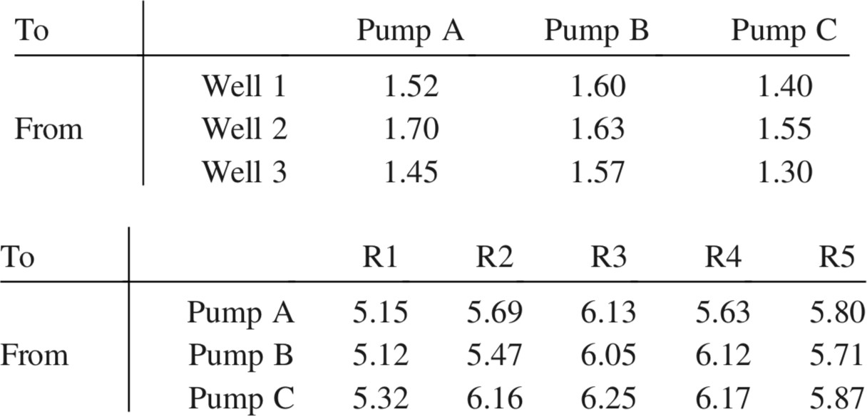

* 1. What is the minimum cost of providing oil to the refineries? Which wells are used to capacity in the optimal schedule? Formulation of the problem is enough.

**ANS)**

**Decision Variables:**

Xijk – Where X represents the units of oil (in TBD) extracted from well i and moved to refinery k via pump station j. (i = 1,2,3) (j = A, B, C) (k = 1,2,3,4,5)

**Objective Function:**

Z = (1.52 + 5.15)*X1A1 + (1.52 + 5.69)*X1A2 + (1.52 + 6.13)*X1A3 + (1.52 + 5.63)*X1A4 + (1.52 + 5.80)*X1A5 + (1.60 + 5.12)*X1B1 + (1.60 + 5.47)*X1B2 + (1.60 + 6.05)*X1B3 + (1.60 + 6.12)*X1B4 + (1.60 + 5.71)*X1B5 + (1.40 + 5.32)*X1C1 + (1.40 + 6.16)*X1C2 + (1.40 + 6.25)*X1C3 + (1.40 + 6.17)*X1C4 + (1.40 + 5.87)*X1C5 + (1.70 + 5.15)*X2A1 + (1.70 + 5.69)*X2A2 + (1.70 + 6.13)*X2A3 + (1.70 + 5.63)*X2A4 + (1.70 + 5.80)*X2A5 + (1.63 + 5.12)*X2B1 + (1.63 + 5.47)*X2B2 + (1.63 + 6.05)*X2B3 + (1.63 + 6.12)*X2B4 + (1.63 + 5.71)*X2B5 + (1.55 + 5.32)*X2C1 + (1.55 + 6.16)*X2C2 + (1.55 + 6.25)*X2C3 + (1.55 + 6.17)*X2C4 + (1.55 + 5.87)*X2C5 + (1.45 + 5.15)*X3A1 + (1.45 + 5.69)*X3A2 + (1.45 + 6.13)*X3A3 + (1.45 + 5.63)*X3A4 + (1.45 + 5.80)*X3A5 + (1.57 + 5.12)*X3B1 + (1.57 + 5.47)*X3B2 + (1.57 + 6.05)*X3B3 + (1.57 + 6.12)*X3B4 + (1.57 + 5.71)*X3B5 + (1.30 + 5.32)*X3C1 + (1.30 + 6.16)*X3C2 + (1.30 + 6.25)*X3C3 + (1.30 + 6.17)*X3C4 + (1.30 + 5.87)*X3C5

**Subject to Constraints:**

X1A1 + X1A2 + X1A3 + X1A4 + X1A5 + X1B1 + X1B2 + X1B3 + X1B4 + X1B5 + X1C1 + X1C2 + X1C3 + X1C4 + X1C5 <= 93

X2A1 + X2A2 + X2A3 + X2A4 + X2A5 + X2B1 + X2B2 + X2B3 + X2B4 + X2B5 + X2C1 + X2C2 + X2C3 + X2C4 + X2C5 <= 88

X3A1 + X3A2 + X3A3 + X3A4 + X3A5 + X3B1 + X3B2 + X3B3 + X3B4 + X3B5 + X3C1 + X3C2 + X3C3 + X3C4 + X3C5 <= 95

X1A1 + X1B1 + X1C1 + X2A1 + X2B1 + X2C1 + X3A1 + X3B1 + X3C1 = 30

X1A2 + X1B2 + X1C2 + X2A2 + X2B2 + X2C2 + X3A2 + X3B2 + X3C2 = 57

X1A3 + X1B3 + X1C3 + X2A3 + X2B3 + X2C3 + X3A3 + X3B3 + X3C3 = 48

X1A4 + X1B4 + X1C4 + X2A4 + X2B4 + X2C4 + X3A4 + X3B4 + X3C4 = 91

X1A5 + X1B5 + X1C5 + X2A5 + X2B5 + X2C5 + X3A5 + X3B5 + X3C5 = 48

And

Xijk >= 0 (i = 1,2,3) (j = A,B,C) (k = 1,2,3,4,5)

* 1. Show the network diagram corresponding to the solution in (a). That is, label each of the arcs in the solution and verify that the flows are consistent with the given information.

**ANS)**

**Network Diagram:**

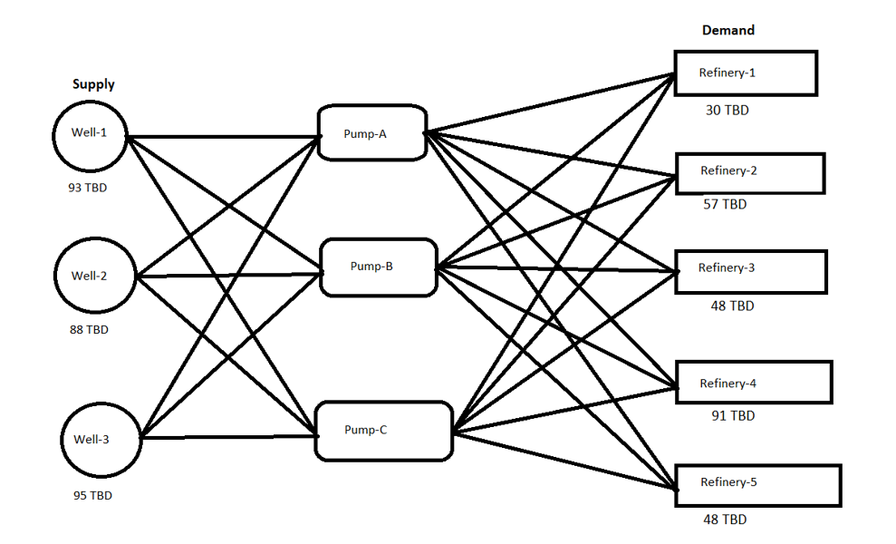

**Relationships:**

Well-1 – Pump-A = 1.52 Pump-A – Refinery-1 = 5.15

Well-1 – Pump-B = 1.60 Pump-A – Refinery-2 = 5.15

Well-1 – Pump-C = 1.40 Pump-A – Refinery-3 = 5.15

Well-2 – Pump-A = 1.70 Pump-A – Refinery-4 = 5.15

Well-2 – Pump-B = 1.63 Pump-A – Refinery-5 = 5.15

Well-2 – Pump-C = 1.55 Pump-B – Refinery-1 = 5.15

Well-3 – Pump-A = 1.45 Pump-B – Refinery-2 = 5.15

Well-3 – Pump-B = 1.57 Pump-B – Refinery-3 = 5.15

Well-3 – Pump-C = 1.30 Pump-B – Refinery-4 = 5.15

Pump-B – Refinery-5 = 5.15

Pump-C – Refinery-1 = 5.15

Pump-C – Refinery-2 = 5.15

Pump-C – Refinery-3 = 5.15

Pump-C – Refinery-4 = 5.15

Pump-C – Refinery-5 = 5.15